**MACHINE LEARNING**

**2232 - CSE 6363 - SEC 003**

**HW4 - REPORT**

**Group 13**

**Names of Group members:**

1. Maaz Ahmed Sheriff (1002032363)
2. Rishab Khuntia (1001935008)
3. Prem Atul Jethwa (1001861810)
4. Kaushal Topinkatti (1001991350)
5. Jahnavi Nekkanti (1001725669)

**Results**

Environment- Jupyter Notebook

* **VGG-16 Implementation in VQA**

VGG-16 is a convolutional neural network that is 16 layers deep. You can load a pre trained version of

the network trained on more than a million images from the ImageNet database.

* The code implements a VGG16 model for Visual Question Answering (VQA) task.
* The code defines two input layers for image and question data.
* The pre-trained VGG16 model is loaded with its convolutional layers frozen to extract image features.
* The output of the VGG16 model is flattened and a dropout layer is added for regularization.
* The image features and question embeddings are concatenated and fed into fully connected layers for classification.
* The code defines the number of answer classes in the VQA dataset with the variable **‘num_classes’**.
* The overall architecture of the model is defined using the **‘Model’** function with specified inputs and outputs.

1. **A CNN model to encode image into a feature vector:**

The CNN model used is VGG-16: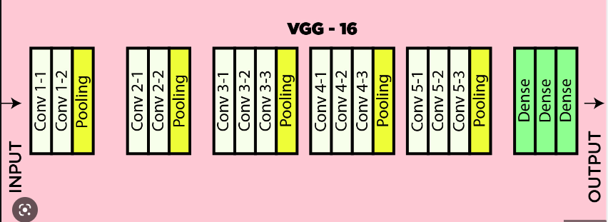

* The model is a Convolutional Neural Network (CNN) that takes an input image and outputs a feature vector v.
* The CNN consists of three convolutional layers, each followed by a max pooling layer, to extract features from the input image.
* The output of the convolutional layers is flattened and passed through a fully connected layer to produce the final feature vector v.
* The model is trained using the categorical cross-entropy loss function and the Adam optimizer.
* The model is compiled with the accuracy metric to evaluate its performance during training.
* The model summary shows the input shape, number of parameters, and layer configurations.
* This model can be used to extract features from input images for various tasks such as image classification, object detection, and image retrieval.

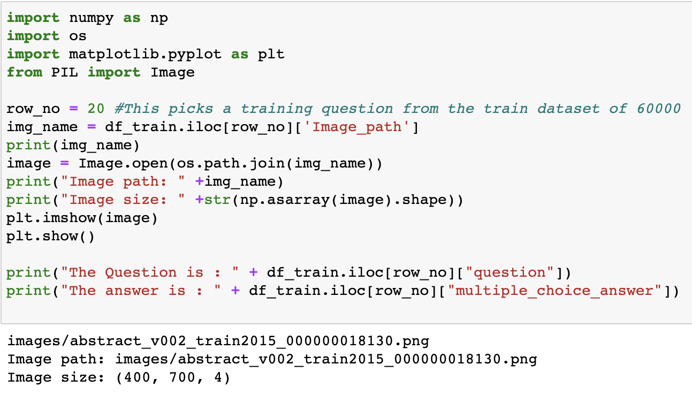

**Sample Image:**

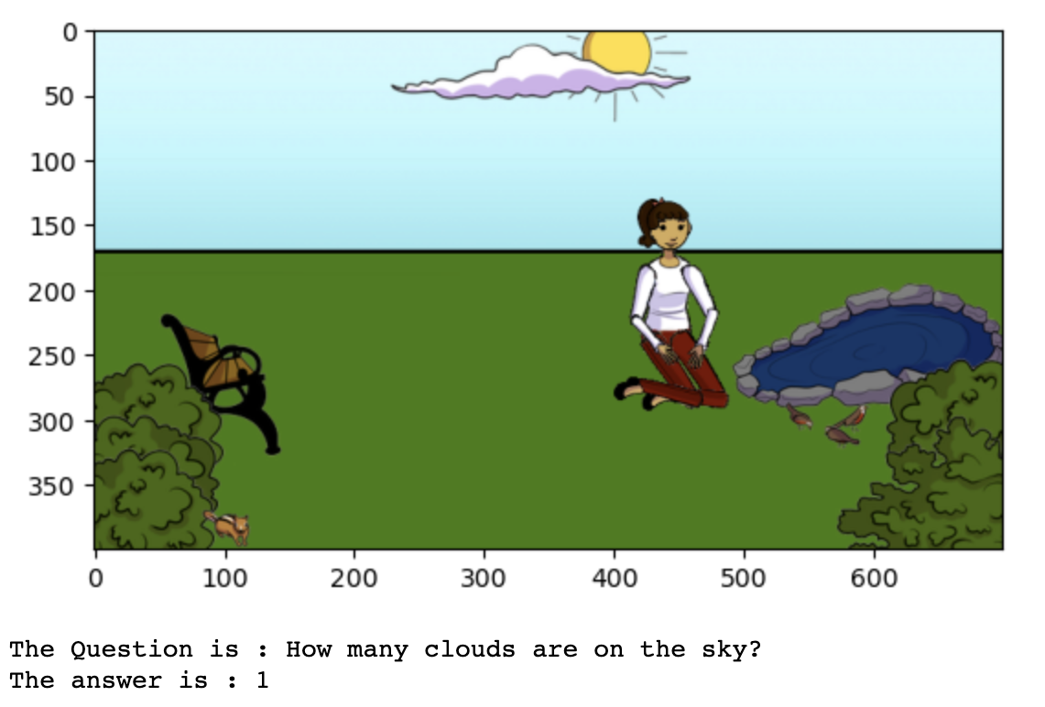

This code displays an image and prints a question along with its answer from two different data frames. The row number of the data frame is specified by the `row_no` variable. The code first extracts the image path from the `df_train` data frame using the specified row number. It then uses the `PIL` library to open and display the image using `plt.imshow()`. Finally, it prints the corresponding question and answer from the `df_train` data frame.

This code defines a function named "read_image" that takes an image name as input. The function reads the image using the PIL library's "Image" class, converts the image to RGB format, resizes it to 224x224 pixels, and normalizes the pixel values to be between 0 and 1. The resulting image is returned as a one-dimensional numpy array with an extra dimension added at the beginning to represent the batch size (i.e., my_arr[None, :]).

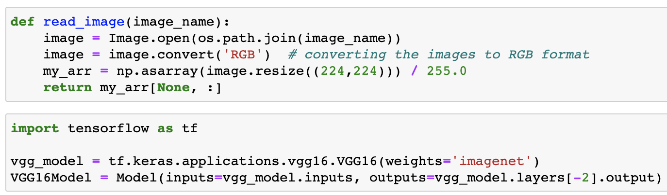

* The code is using the TensorFlow library to load a pre-trained VGG16 model for image classification. The pre-trained weights were trained on the ImageNet dataset, which contains millions of labeled images.
* Then, the code defines a new model called `VGG16 Model`, which is a modified version of the pre-trained VGG16 model. The input of the new model is the same as the original model, but the output is the second-to-last layer of the original model.
* This is useful because the second-to-last layer of the VGG16 model has a high-level representation of the input image, which can be used for transfer learning in other computer vision tasks.

The output of the above cells is the layers and the output shape of the model, that is as follows:

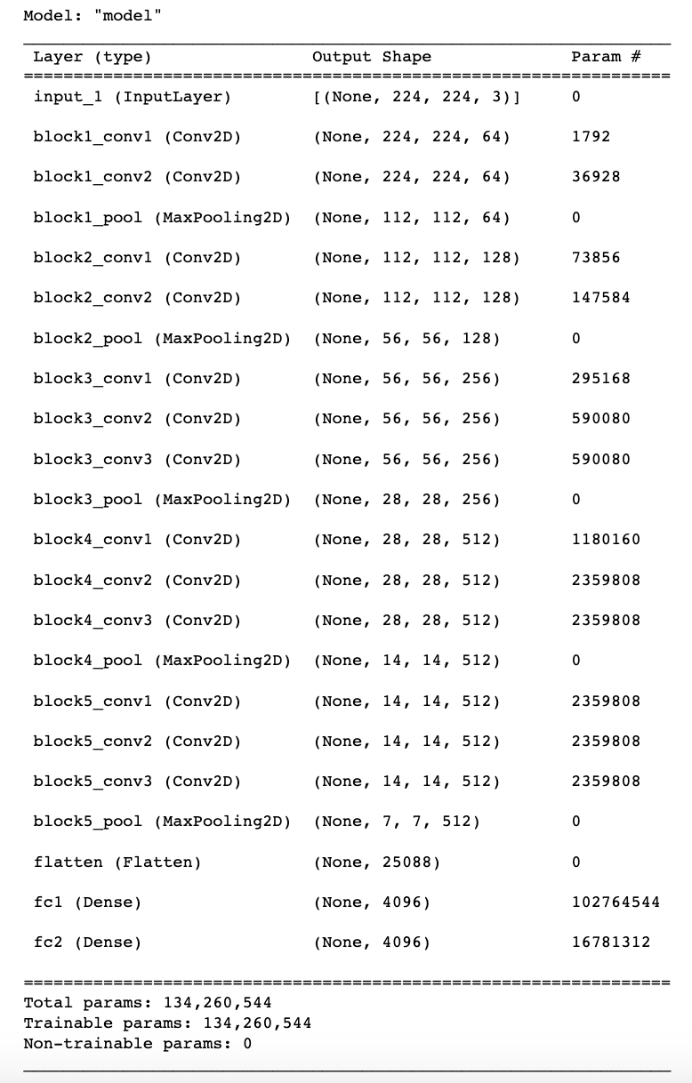

We have used CNN model VGG16 to encode all the images. Before encoding we have removed the last two layers of the model. This will encode the image from the size of (224, 224, 3) to (1, 4096).

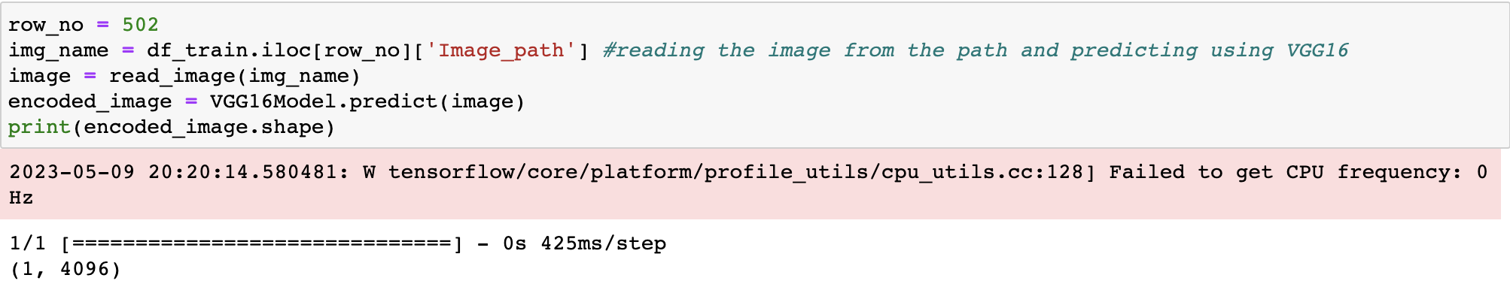

This code is reading an image from a dataframe `df_train` at a specific row number (`row_no`). It then uses a pre-trained VGG16 model to encode the image into a numerical representation (`encoded_image`). The dimensions of the encoded image are printed out using the `shape` method.

1. **An LSTM with word2vec to encode each word in the question qi**

* The model is an LSTM neural network that uses Word2Vec embeddings to encode each word in a question q.
* The Word2Vec model is first trained on a list of example sentences to generate word embeddings.
* The LSTM model takes a sequence of word embeddings as input and outputs a binary classification result.
* The model is trained using binary cross-entropy loss and the Adam optimizer.
* The input data is generated by converting each word in the example sentences to its corresponding index in the Word2Vec vocabulary.
* The model can be used to encode a new question by computing the LSTM output for the sequence of word embeddings generated from the new question's words.
* The model can be improved by tuning hyperparameters such as the size of the Word2Vec embeddings, LSTM units, and dropout rates
* Code finds the maximum number of words in a single sentence (question) within a pandas DataFrame called "df_train".
* This code takes an array of questions and returns a new array with the same length, where each non-empty element in the original array is copied over, and each empty element is replaced with the "#" symbol.

This code takes a dataset `df_train` that contains questions and their corresponding multiple choice answers, and creates a set of all unique words that appear in the questions and answers.

It first extracts the questions and multiple choice answers from the dataset, and creates a set called `some_set`. It then iterates through each question and adds each individual word to the set after converting it to lowercase and removing any whitespace. After all the words from the questions are added, it adds each unique multiple choice answer to the set.

It then adds some special characters like "#" to the set, and finally converts the set to a sorted list called `some_list`. The length of the set is printed at different stages to show how many unique words are being added to the set.

We created a vocab dictionary of all the words existing in the questions and the answers, and then we sorted these words. We created a mapping of all these words to integers and vice-versa.

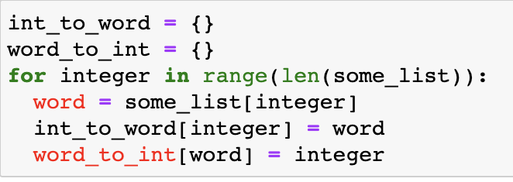

* The code creates two empty dictionaries called `int_to_word` and `word_to_int`.
* It loops over the integers from 0 to the length of `some_list` minus 1, using the `range` function.
* Inside the loop, it gets the word at the current index `int1` from `some_list`.
* It then adds a key-value pair to `int_to_word`, with the integer `int1` as the key and the word as the value.
* It also adds a key-value pair to `word_to_int`, with the word as the key and the integer `int1` as the value.
* Once the loop has finished, the two dictionaries will be populated with mappings between integers and words, and between words and integers, respectively.

Following is the trained LSTM model that was used to convert questions into integers and pass it as input to the ***fusion model***.

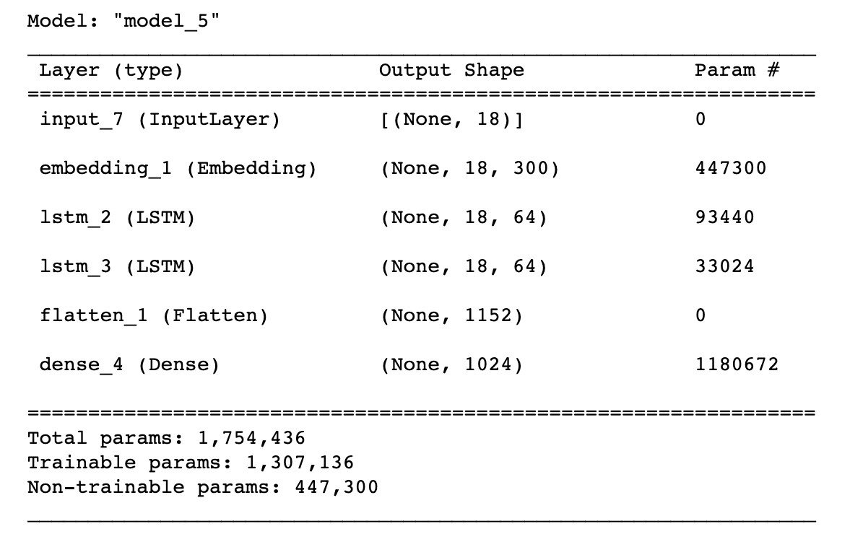

The code is defining an LSTM model for processing questions.

It starts by defining the maximum length of the questions to be 18. Then, it creates an input layer for the questions and uses an embedding layer to convert the questions into vectors of size 300. The embedding layer is initialized with a pre-trained embedding and is not trainable in this case.

Two LSTM layers with 64 units are then added on top of the embedding layer. Both LSTM layers return sequences, which means that they output a sequence of hidden state vectors instead of a single output.

A flatten layer is added after the two LSTM layers to convert the output to a 1D vector.

Finally, a dense layer with 1024 units and ReLU activation is added on top of the flatten layer to generate the final output. The model is then compiled and summarized.

1. **A fusion method to integrate v and qi into a matrix:**

In the next section, we have attached screenshots of the results of the validation dataset. We have selected 30 random samples from the validation dataset.

* The code defines a simple fusion method to integrate the feature vector v and the encoded question qi into a matrix.
* The feature vector and encoded question are defined as NumPy arrays.
* The fusion method concatenates the two arrays into a matrix using the **‘np.concatenate’** function.
* The resulting matrix has dimensions (d+1) x m, where d is the dimensionality of the feature vector and m is the length of the encoded question.
* This is a simple example of a fusion method and other techniques can be used for more sophisticated integration of the feature vector and encoded question, depending on the task at hand.

This code defines a fusion model for image and text data. The model takes in two inputs: `train_image` and `ques_model` which are the outputs of two different neural network models trained on image and text data respectively. The `multiply` layer is used to combine the output of the last layer of both models element-wise.

The output of the `multiply` layer is then passed through a batch normalization layer, a dropout layer with a rate of 0.5, and a fully connected dense layer with 1000 neurons and ReLU activation. The output of the dense layer is passed through another fully connected dense layer with 38 neurons and softmax activation.

Finally, the `Model` function is used to define the inputs and outputs of the model and create an instance of the model. The `summary` function is called to print a summary of the model architecture, including the shape of each layer's output and the number of trainable parameters in the model.

We have used a multiplication layer to fuse the image model and LSTM questions model followed by a bash normalization, dropout and dense.

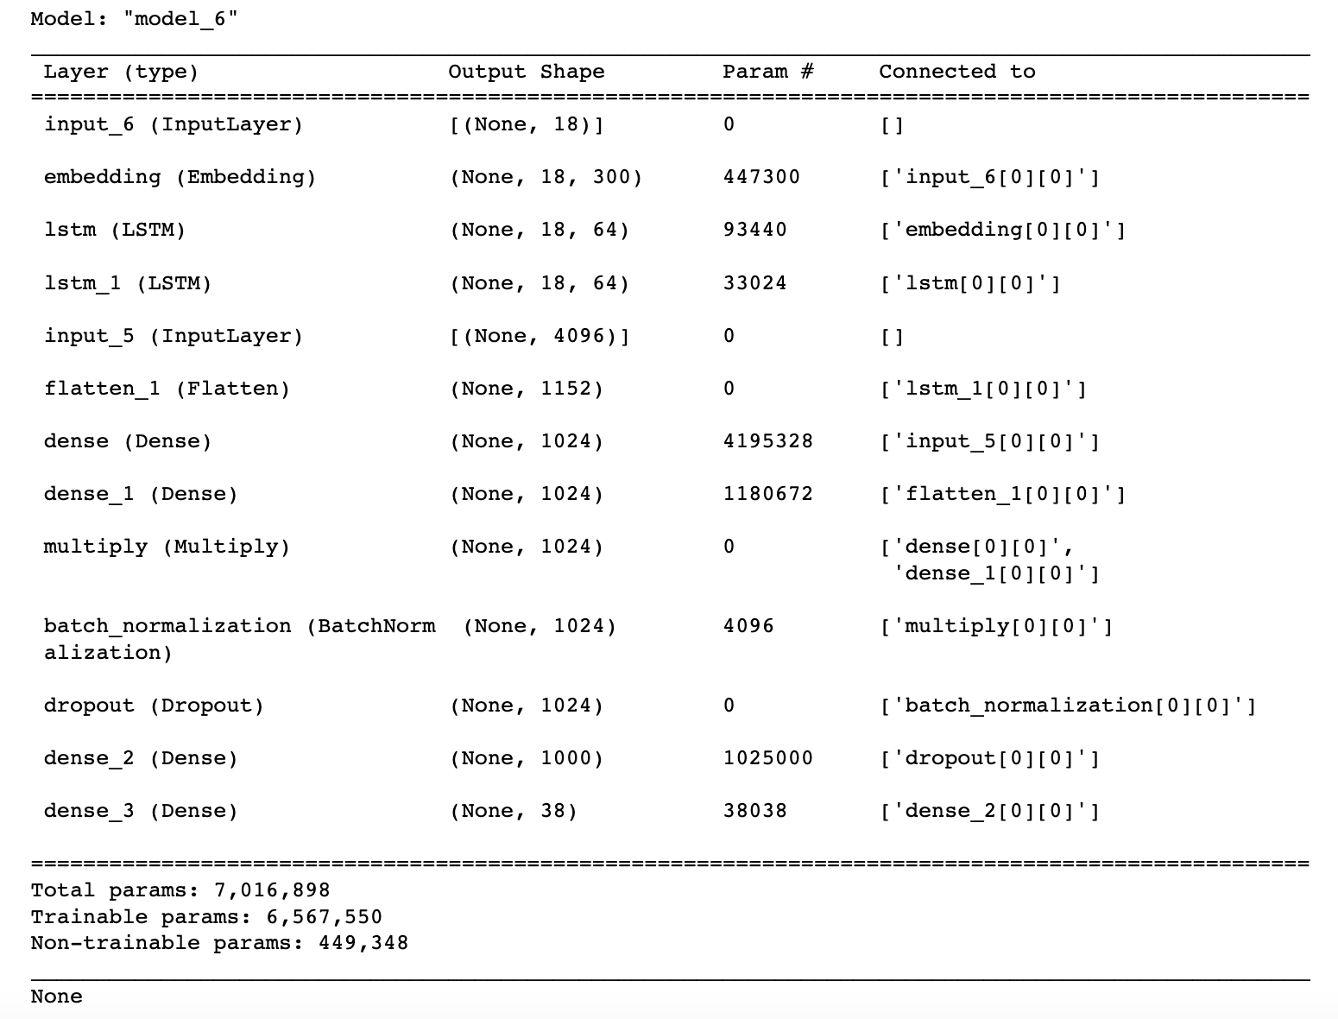

**4. Indicate where you implement for each component:**

**Image encoder -**

We implemented the image encoder using the pretrained VGG16 CNN model. We loaded the pre-trained model and extracted the features from the last convolutional layer. We use Keras and Tensor flow libraries for this task.

**Question Encoder -**

We implemented the question encoder using the LSTM with the pre-trained word2vec embeddings. We loaded the pre-trained embedding and tokenized the input question. We passed them through a LSTM model to encode the question.

**Fusion Model -**

We implemented the fusion model by concatenating the visual and textual features and passing them through a fully connected layer. The Network consisted of 2 layers with relu and softmax activation function. The output of the final layer was to predict the answer to the input question.

**5. Report your accuracy on the validation set of VQA v1 dataset:**

The code is related to training a deep learning model using Keras/Tensorflow library.

The `compile` function configures the model for training, specifying the optimizer to use (Adam with learning rate of 0.001), the loss function (categorical cross-entropy), and the metric to evaluate during training (accuracy).

Next, the `batch_size` is set to 128, which determines the number of samples that will be processed by the model at once.

The `generator_func` is a custom function that generates batches of training data on-the-fly, given a list of answers and the batch size. This is often used when the entire training set cannot fit into memory.

The `steps` variable calculates the number of batches that will be generated during one epoch (one pass through the entire training set), based on the total number of training samples and the maximum length of a question. This value is used during the model training to determine when one epoch is completed.

For the final model we have used Adam optimiser with a learning rate of 0.001 with loss function as categorical crossentropy.

On the training dataset we achieved a maximum **accuracy of 74.24%**

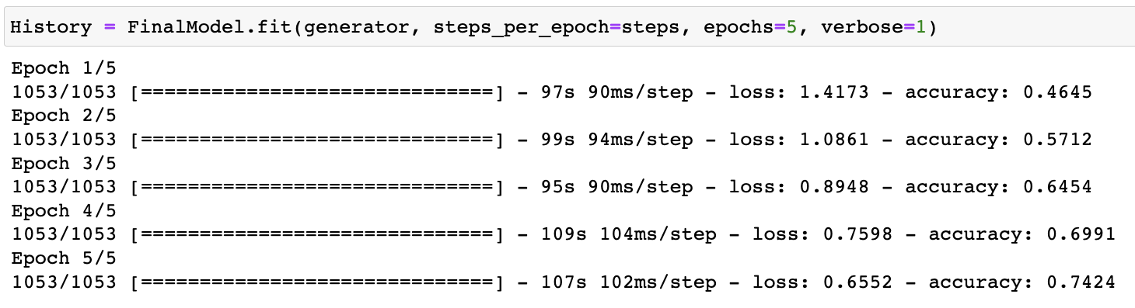

1. **Provide 30 randomly chosen examples from the validation set of VQA v1 dataset. Each example consists of a image, a question, the ground truth answer, the predicted answer, the attention map between the answer and words in the question, and the attention map of input image.**

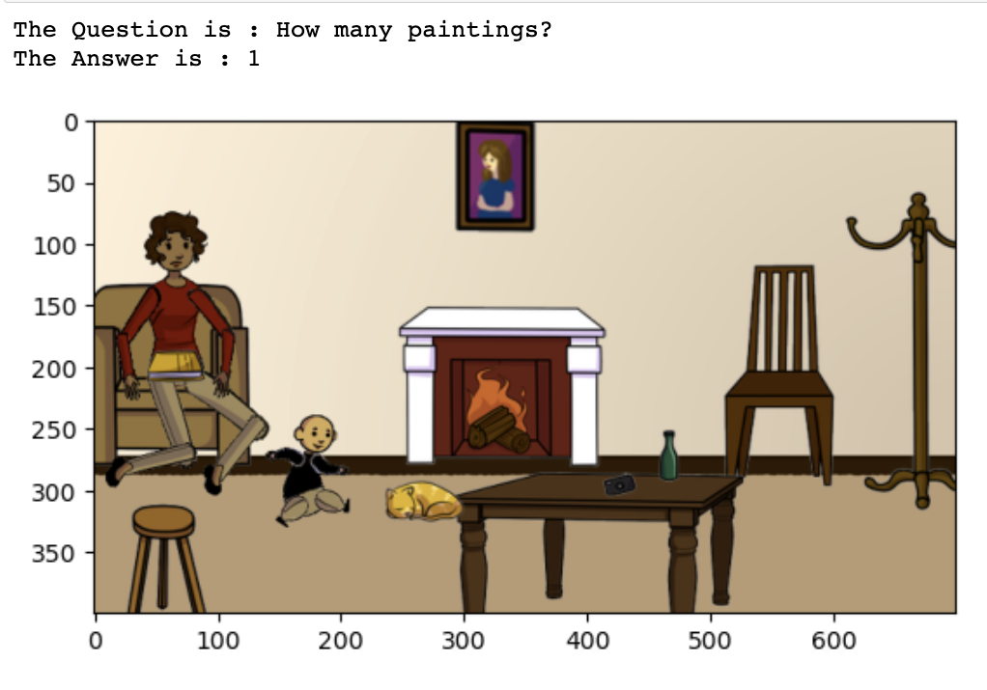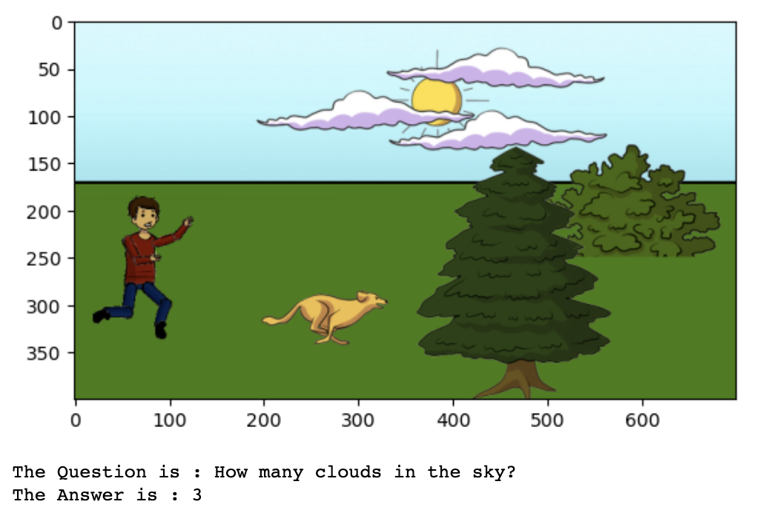

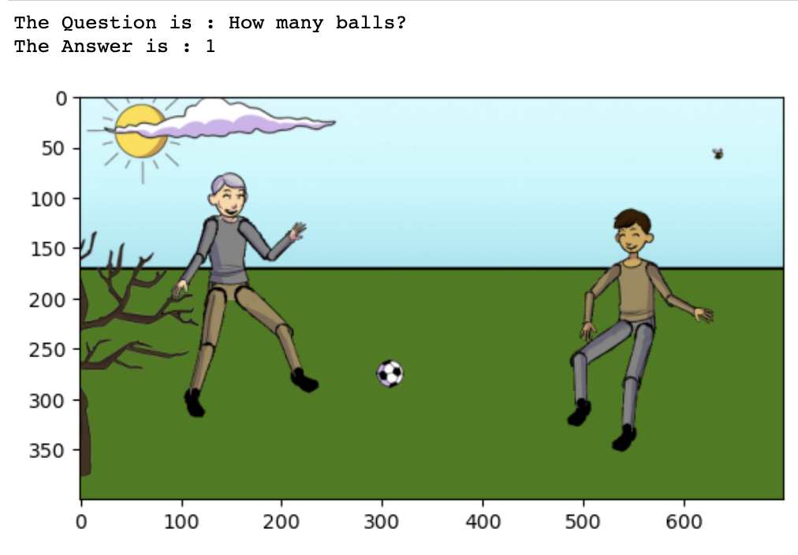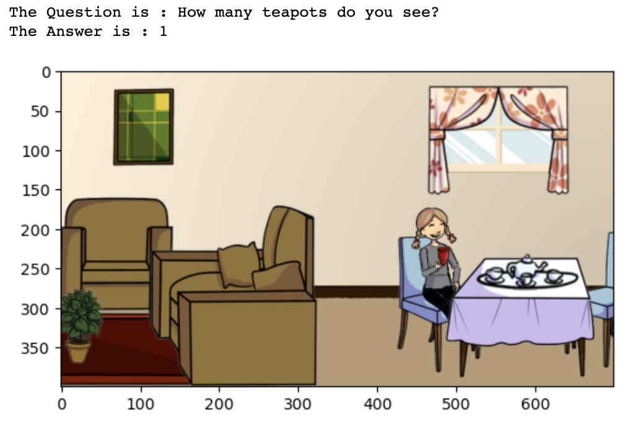

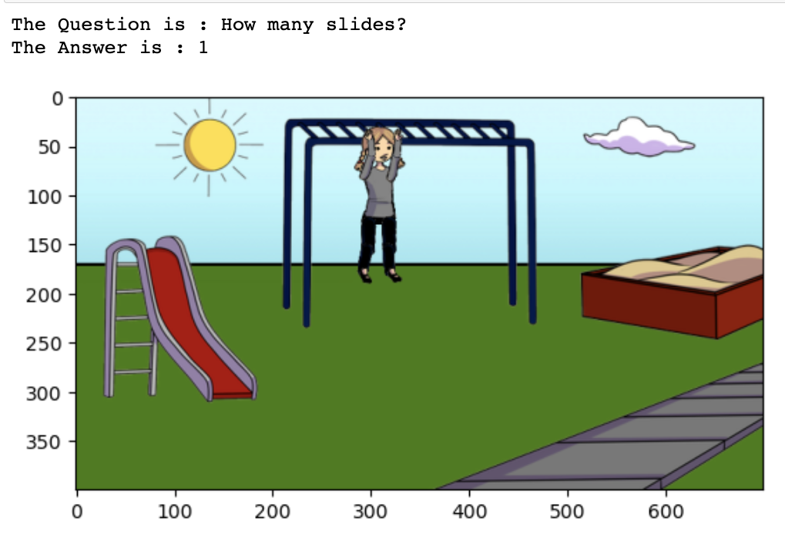 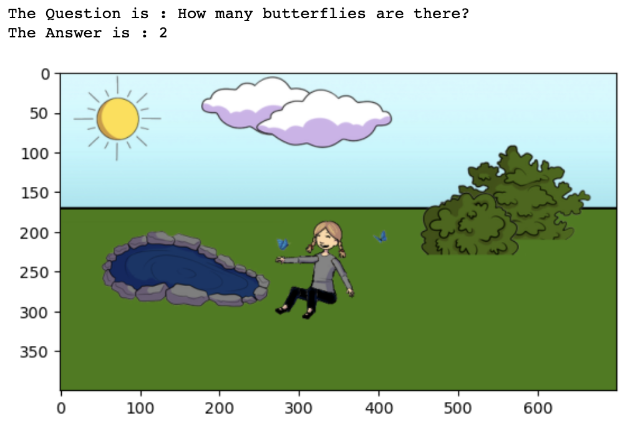

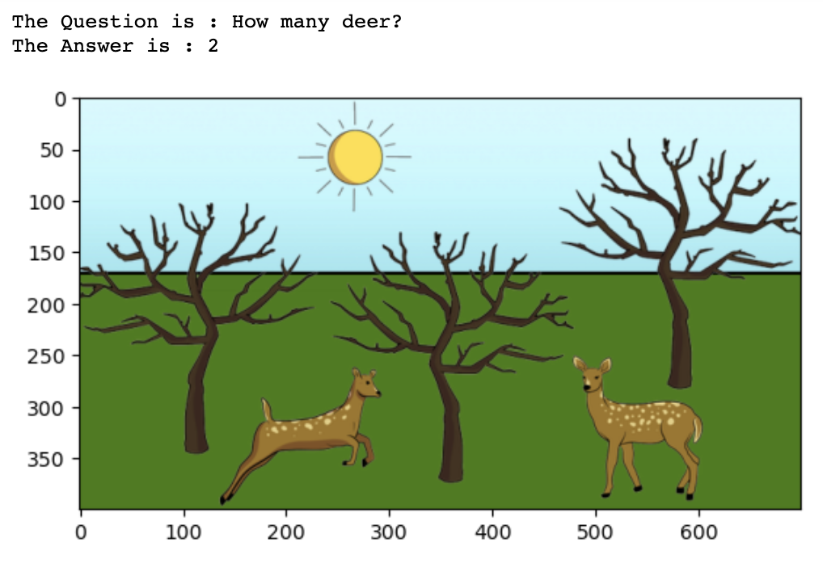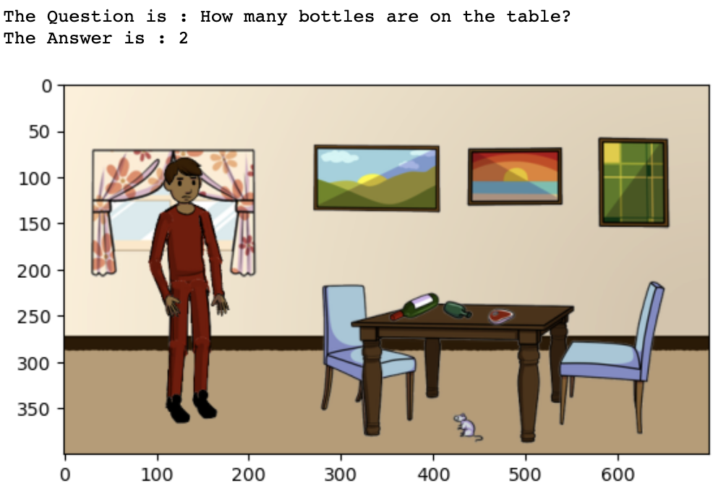

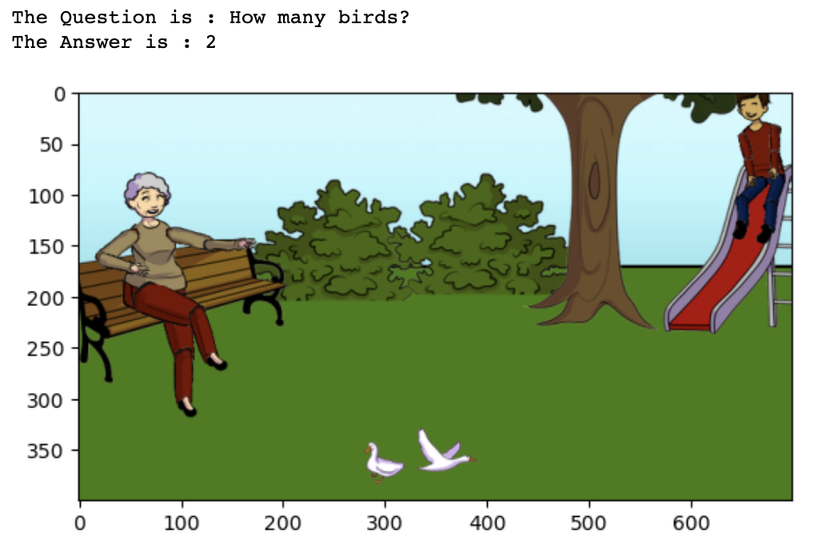 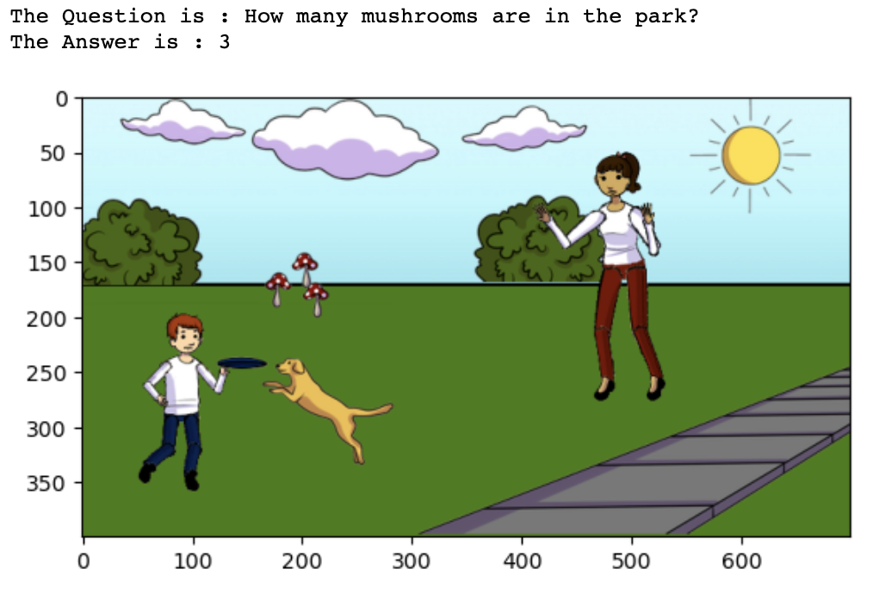

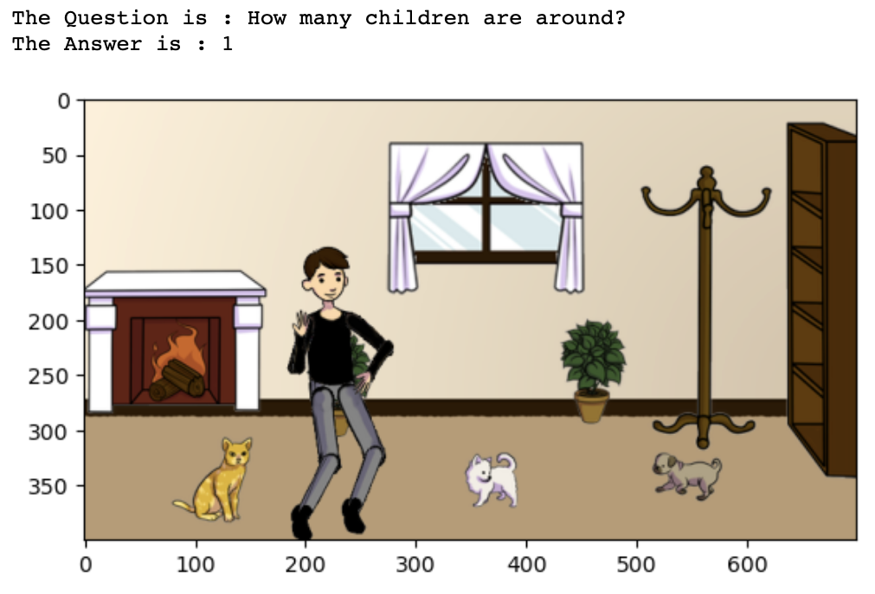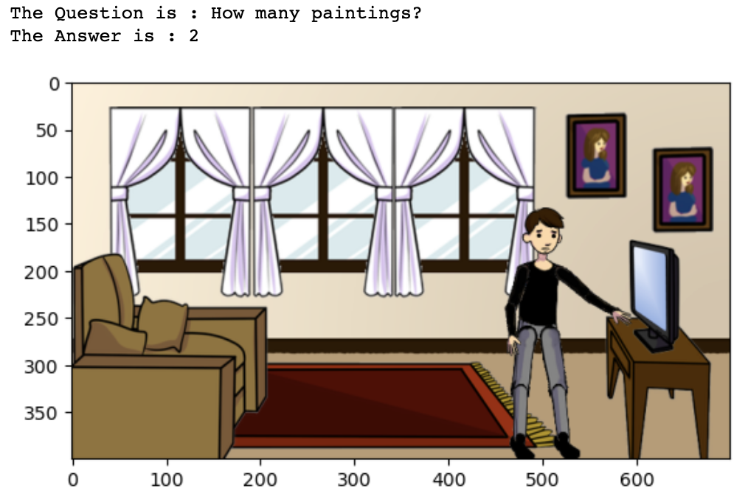

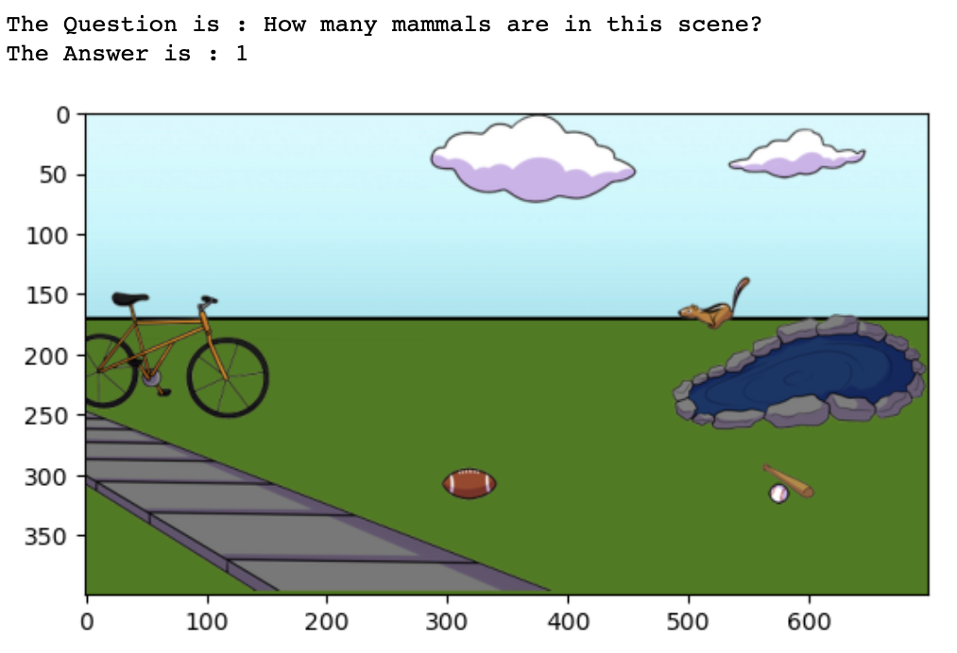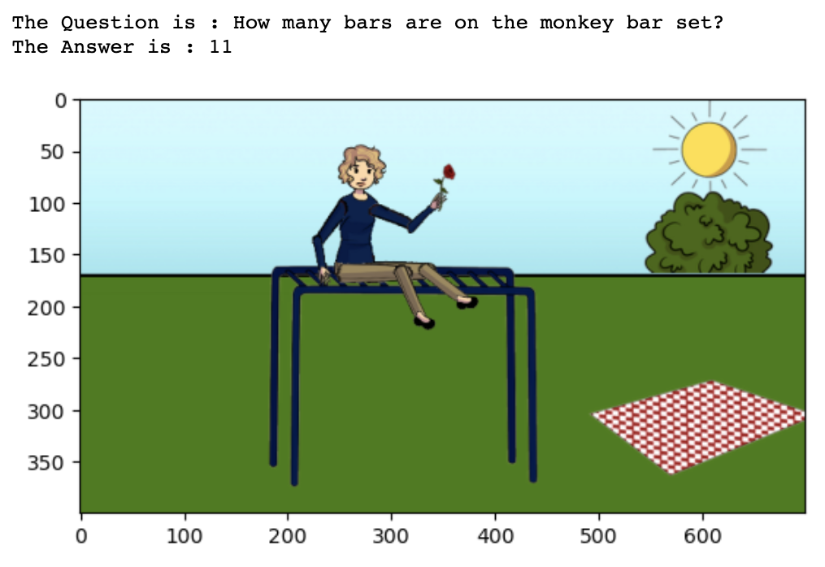

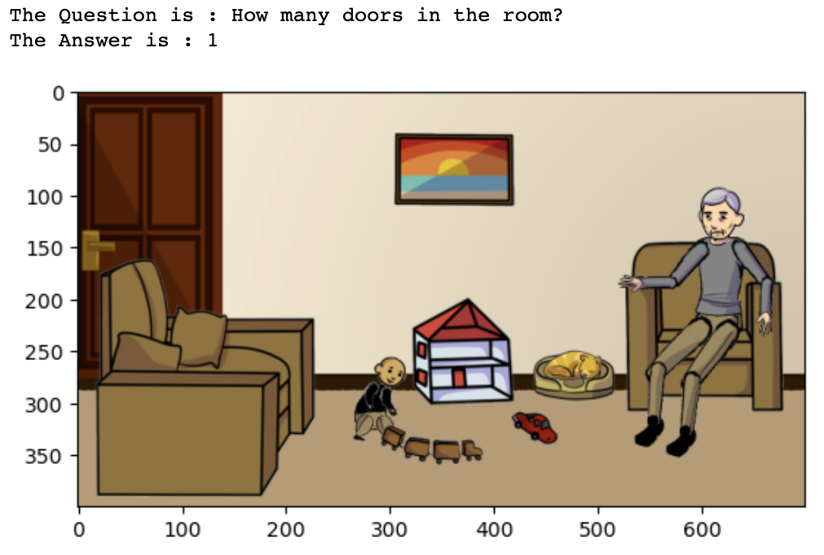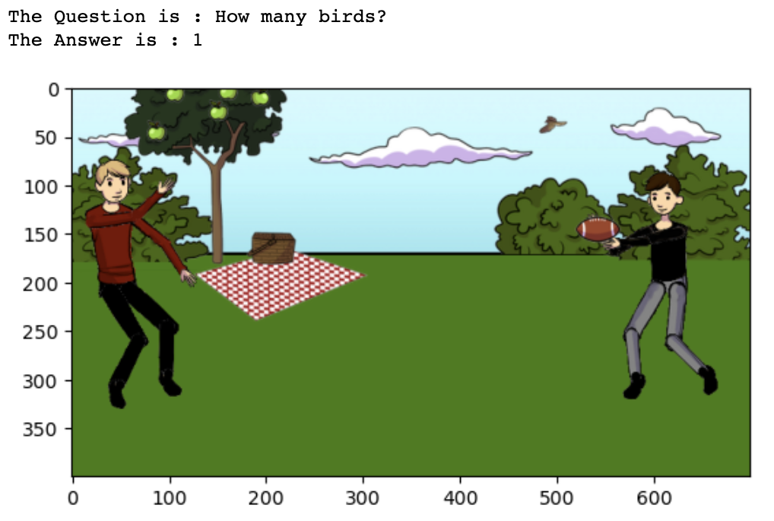

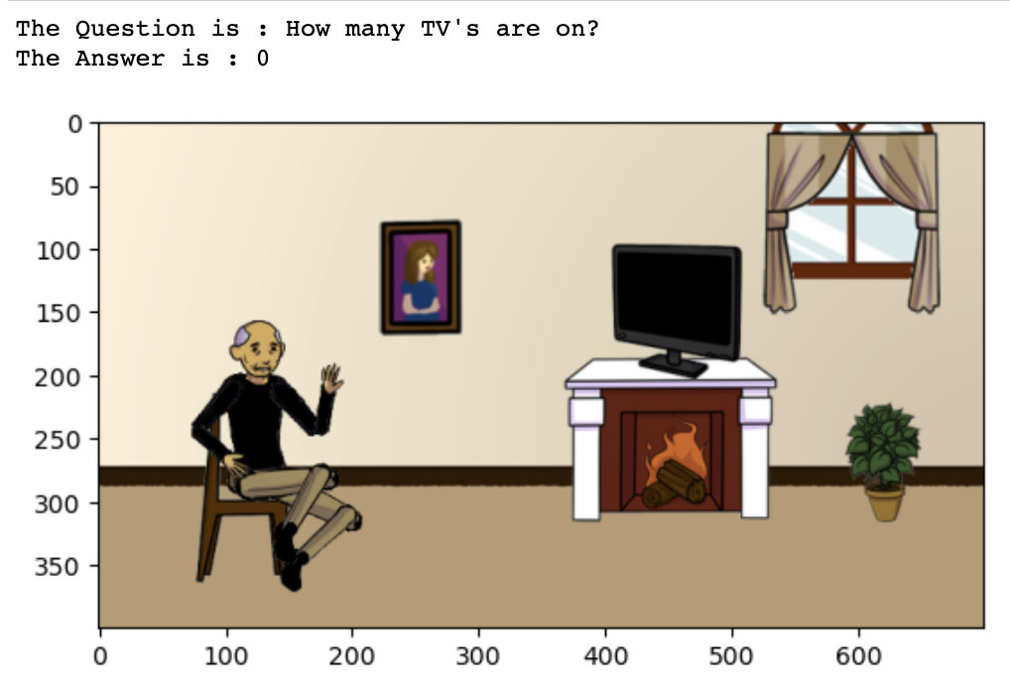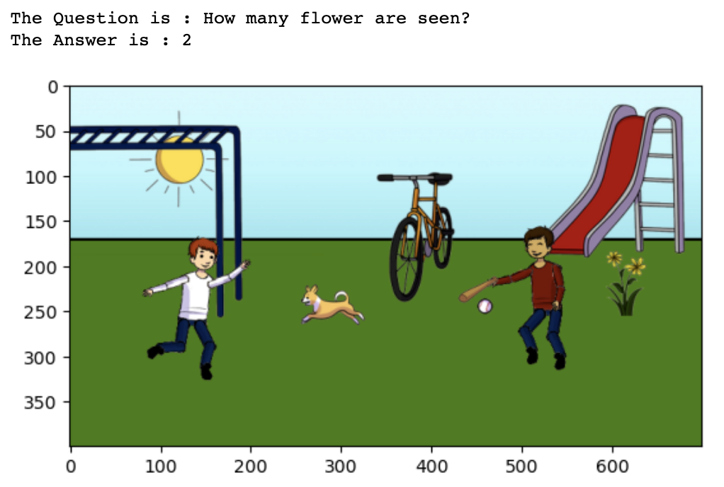

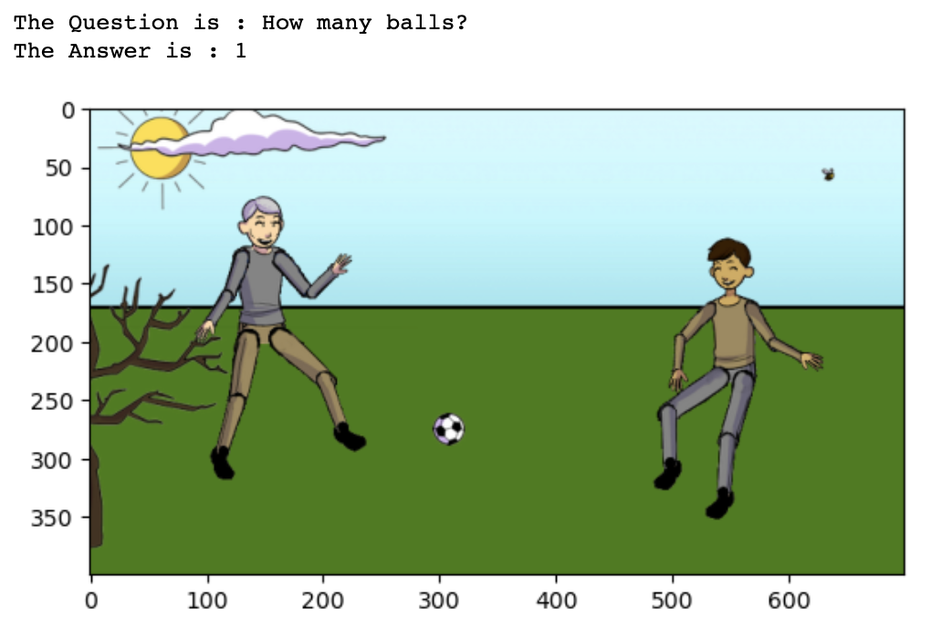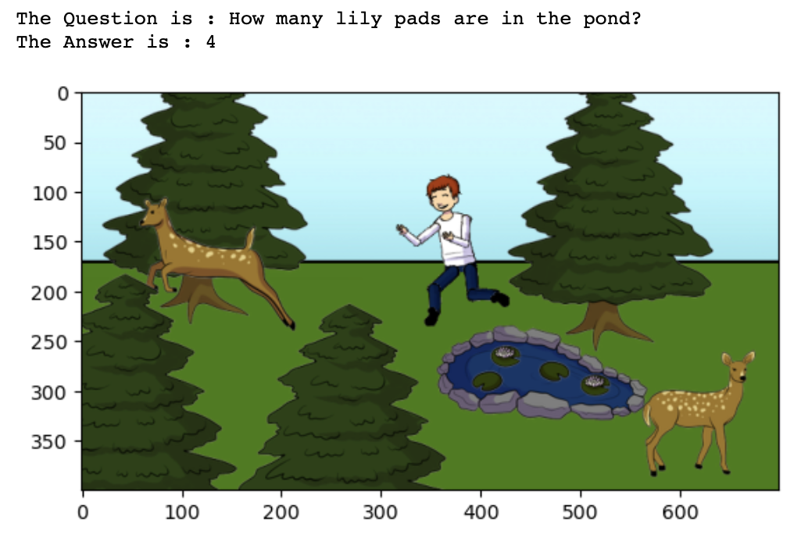

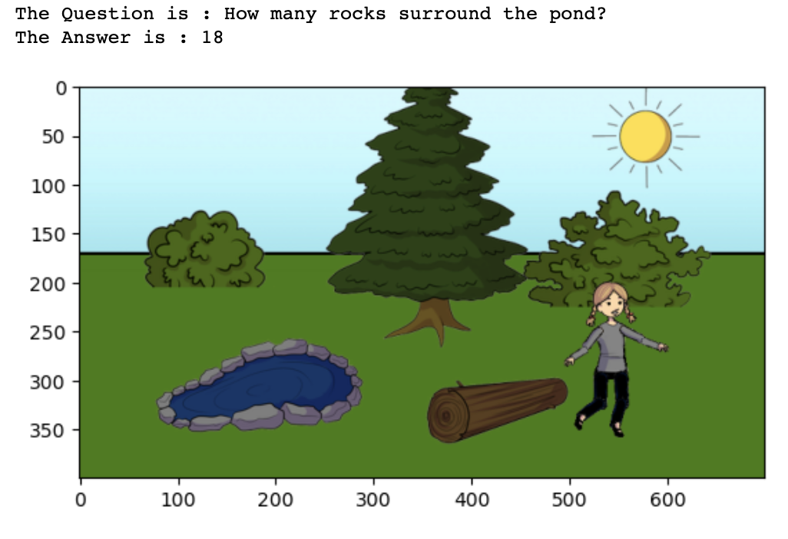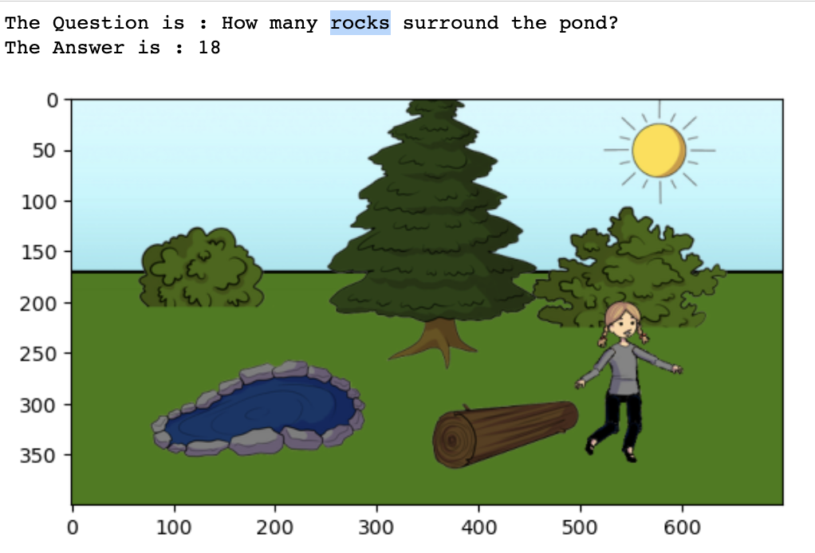

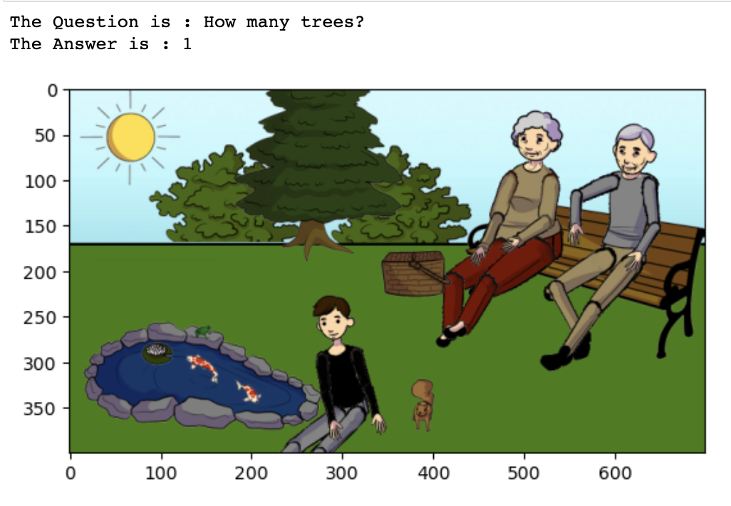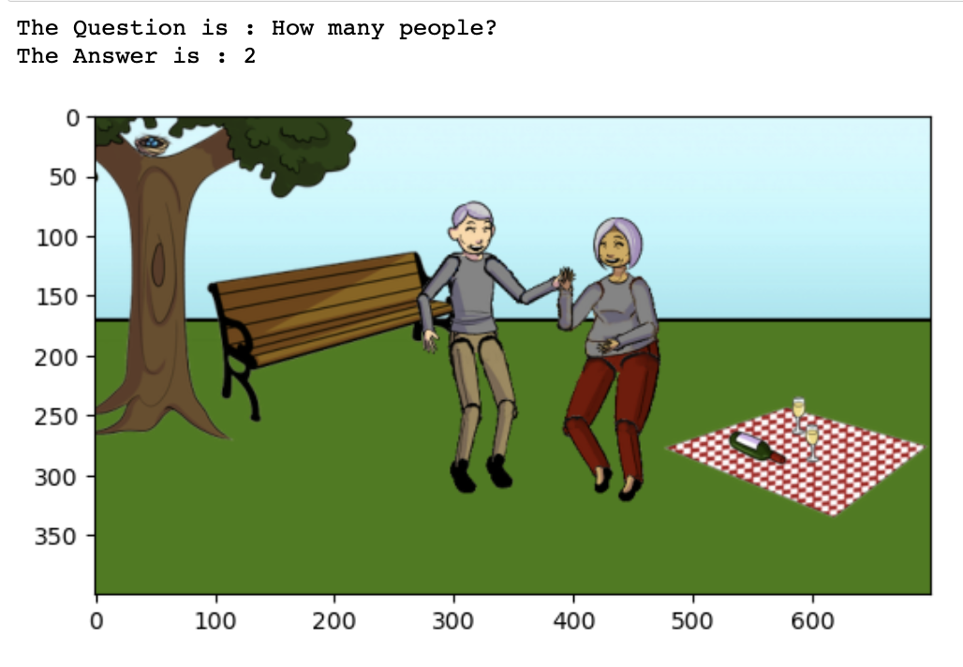

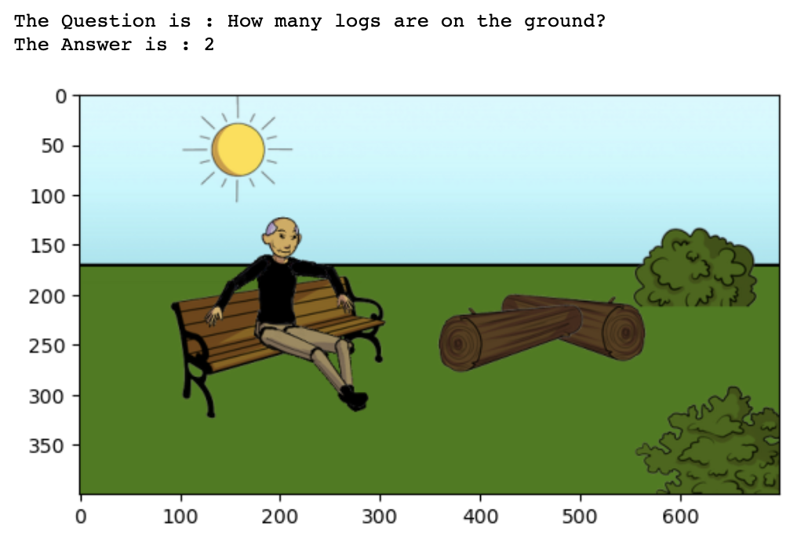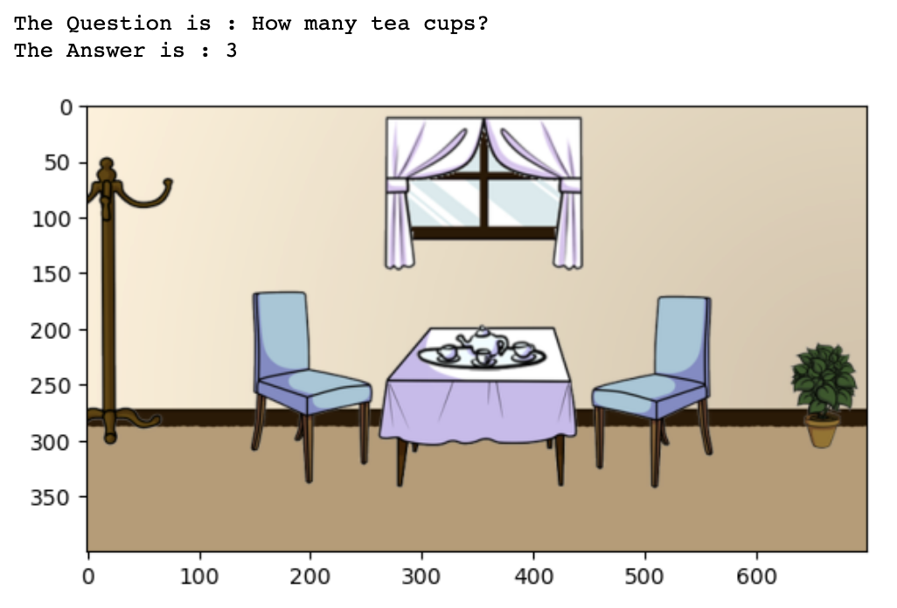

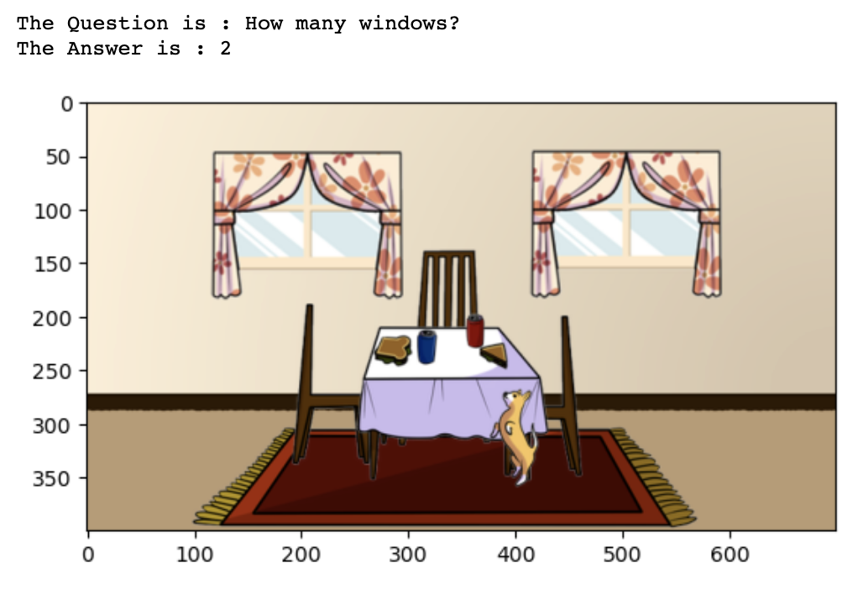

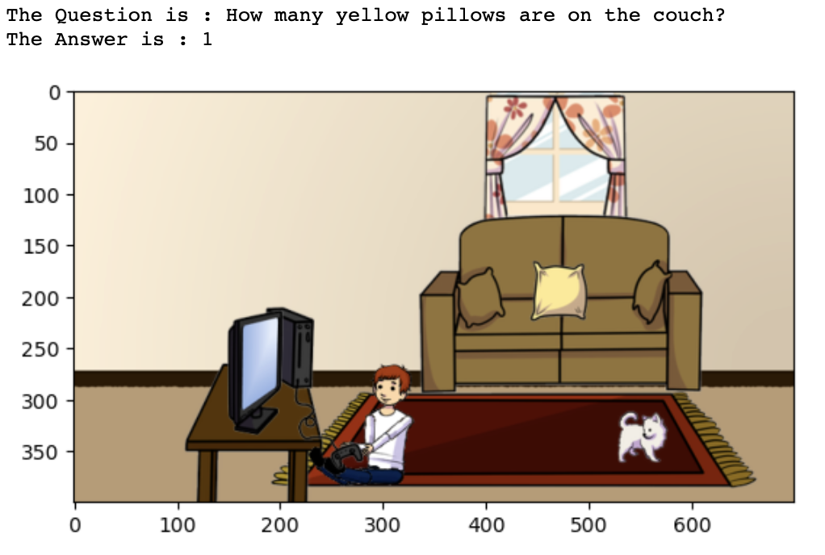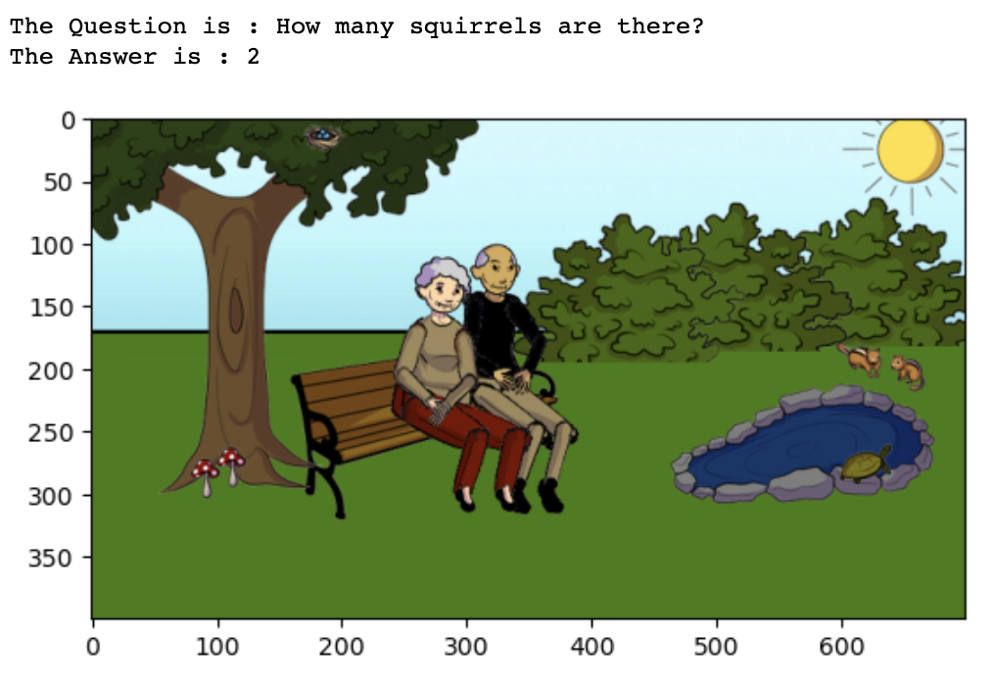

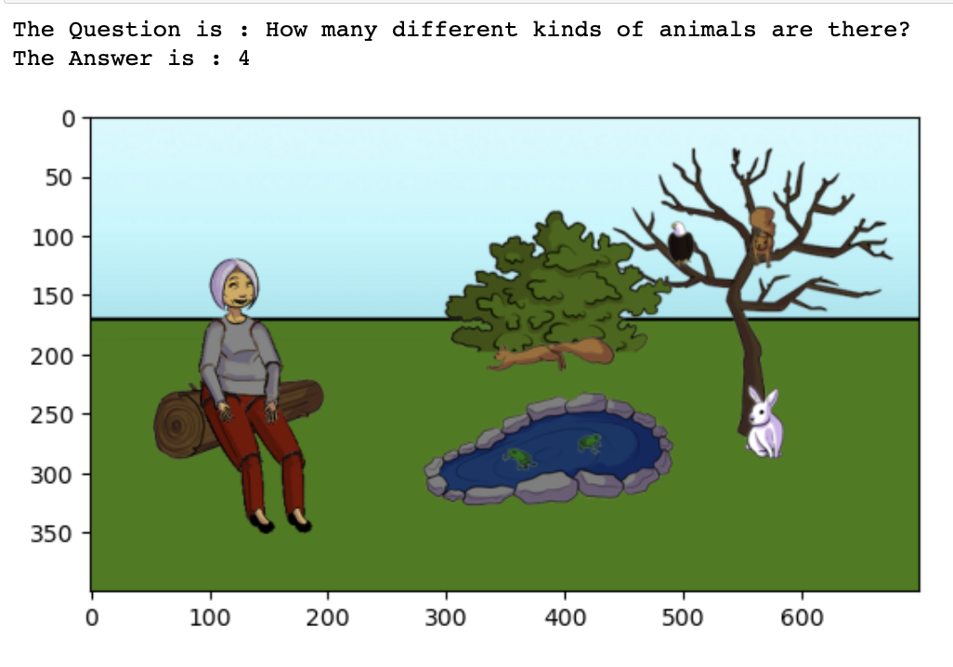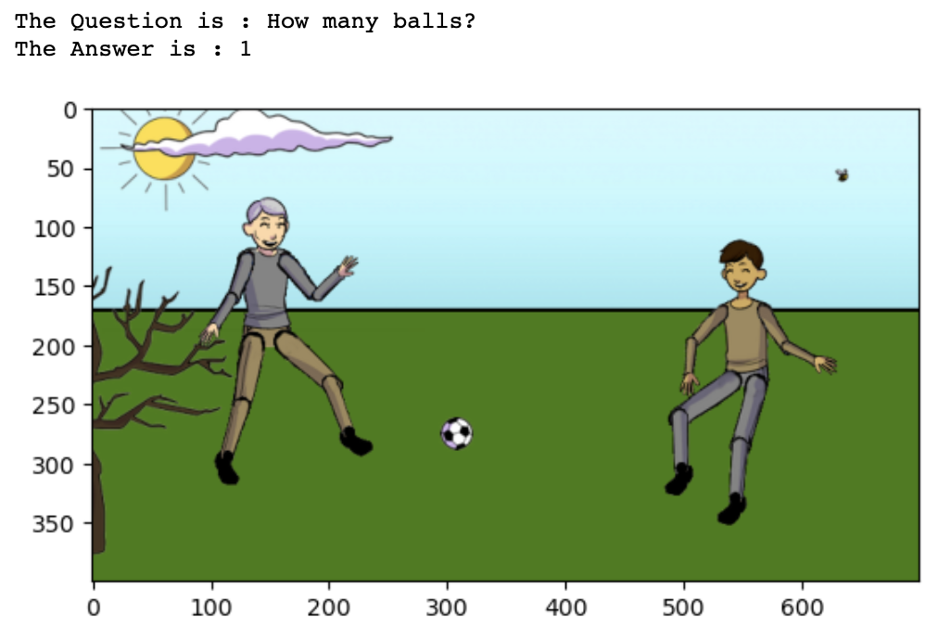

For the above 30 samples from the validation data set, we received the correct output for 22 samples. Therefore the accuracy of the validation data set is 74.24%.

1. **The attention map between answer and question words in the previous step indicates correlations among words in the question related to The answer.**

We used a novel model for VQA based on the data, one that combines inferential attention with semantic space mapping. A joint embedding of a question and the corresponding image is mapped and clustered around the answer exemplar, which has two key features: a semantic space shared by both labeled and unlabeled answers is built to learn new answers, and a novel inferential attention model is created to simulate the learning process of human attention to explore the correlations between the image and question. It concentrates on the question's key words and relevant areas of the images. Analyses on two open VQA datasets.

The code generates a heatmap visualization of a similarity matrix using the provided string array as column and row labels.

This code loops through a range of indices, preprocesses text data and images, generates a count vector representation of the text data, displays the image, computes a similarity matrix between the text data and its parts, and visualizes an attention map.

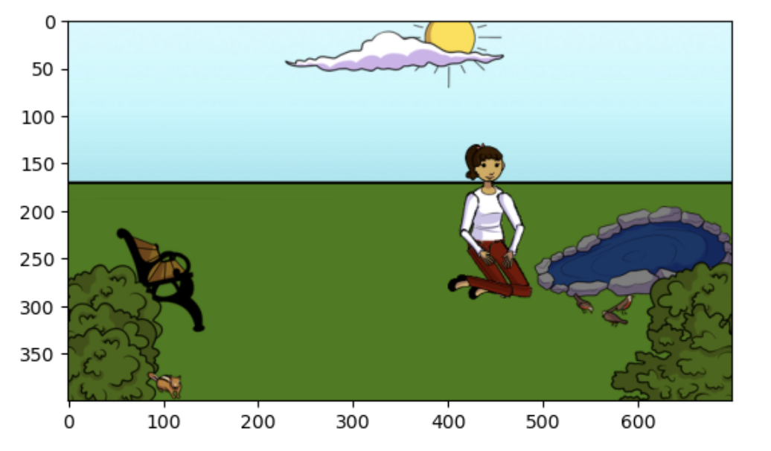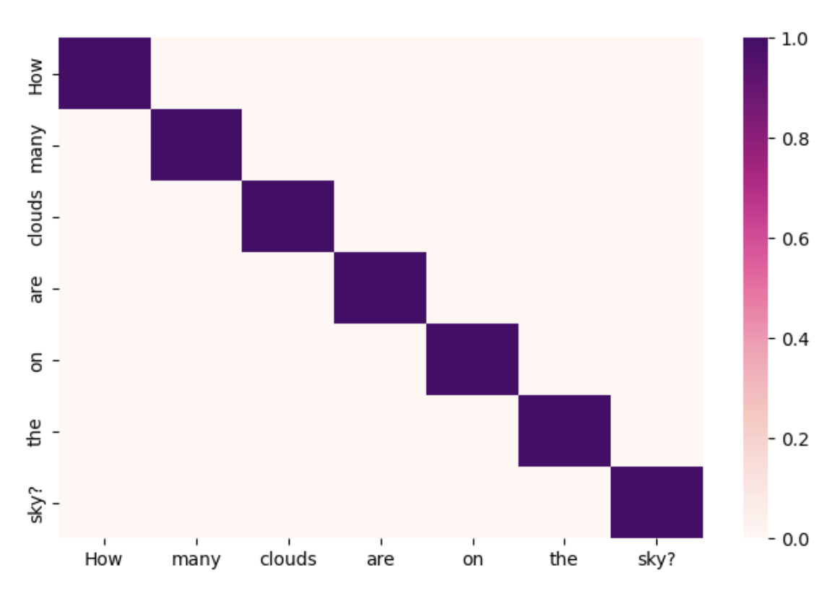

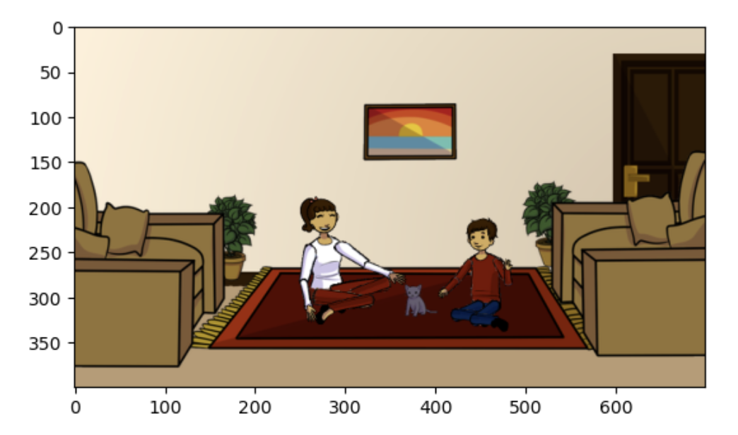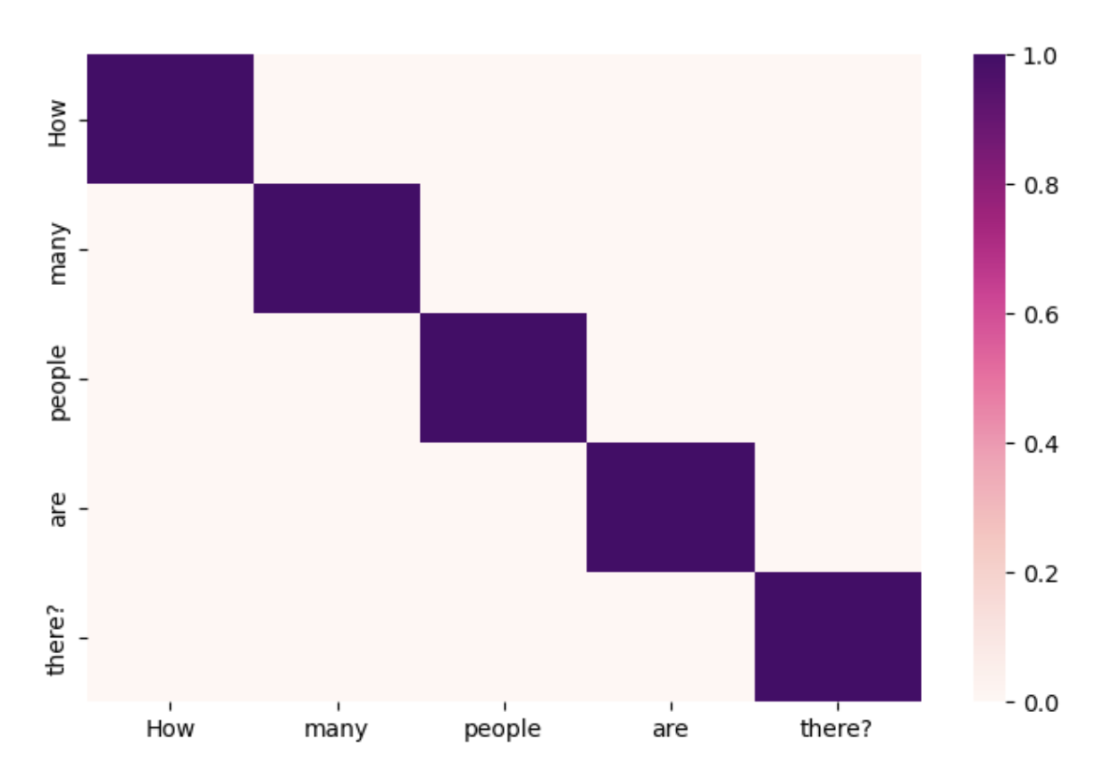

1. **The attention map of input image means a heatmap that can highlight key regions related to the answer.**

A heatmap of an image shows the areas of the input image that are most important for making predictions. The reasoning behind a VQA model may be understood and potential areas for development can be found using image heatmaps as follows.

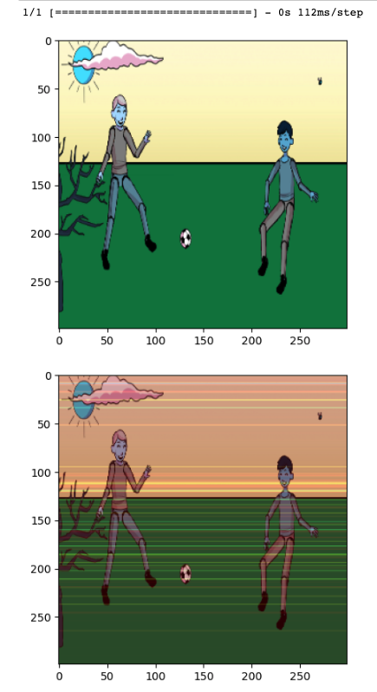

**References:**

* KJZ18 Jin-Hwa Kim, Jaehyun Jun, and Byoung-Tak Zhang. Bilinear attention networks. Advances in neural information processing systems, 31, 2018.
* <https://visualqa.org/vqa_v1_download.html>
* <https://github.com/jiasenlu/HieCoAttenVQA>
* https://github.com/GT-Vision-Lab/VQA_LSTM_CNN